Lab:

**Create pipelines**

1. Go to OpenPipeline and select Logs > Pipelines.
2. Create a pipeline for each service.
   1. Select  Pipeline and enter a pipeline title—for example, Checkout service pipeline for the checkoutservice service.
   2. Select Save

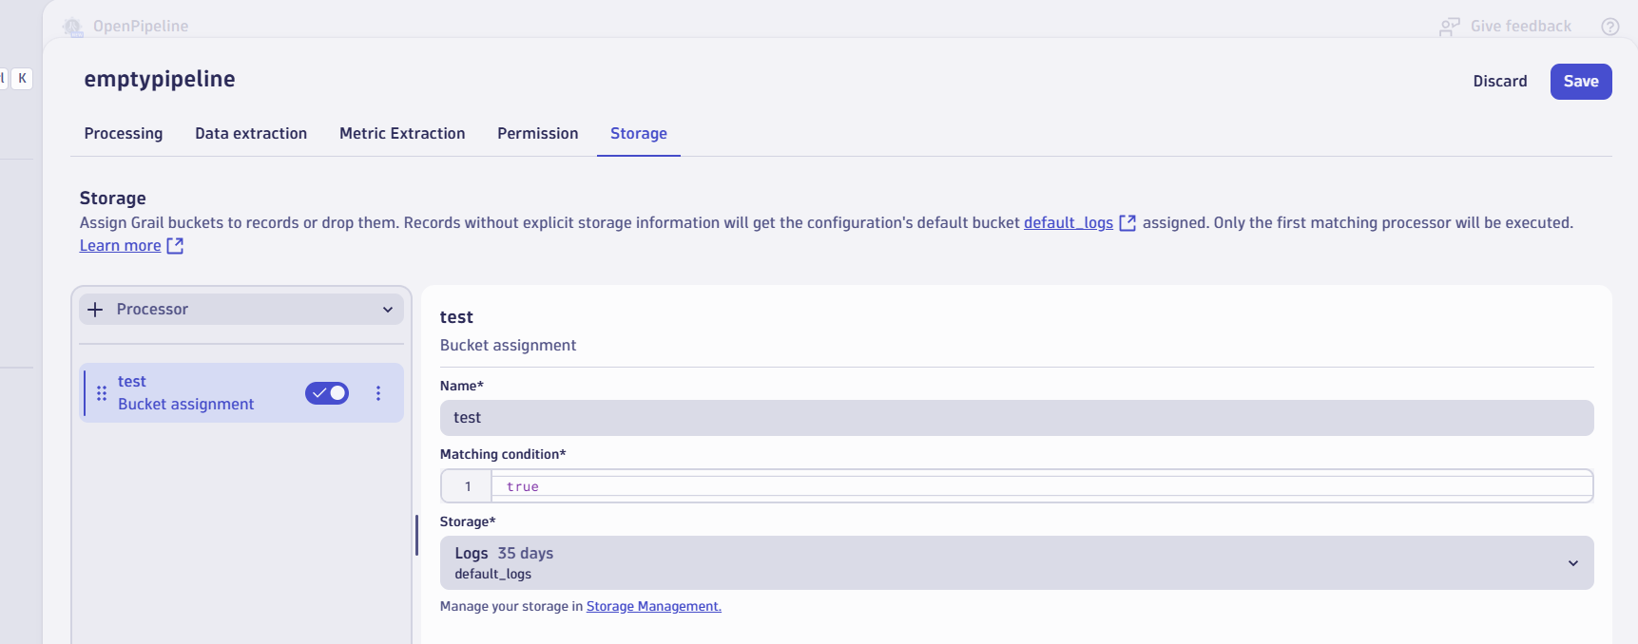

Go to notebook

fetch logs

| summarize logCount = count(), by:{loglevel}

| sort logCount desc

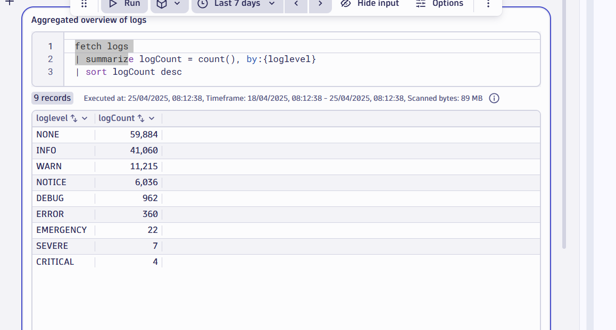

Key value fied is available, where key field represent the loglevel

Now 🡪openpipeline->dynamic routing->Click on Dynamic route

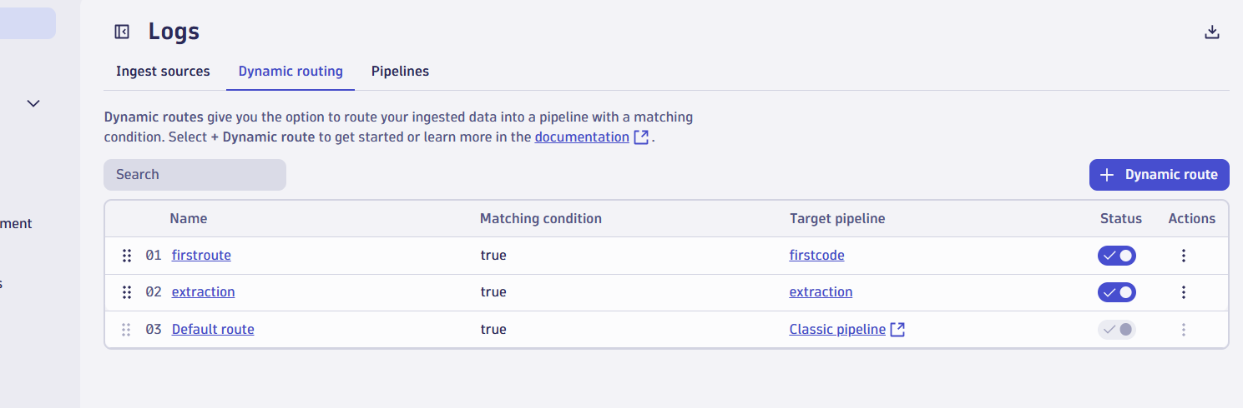

Create a dynamic routing

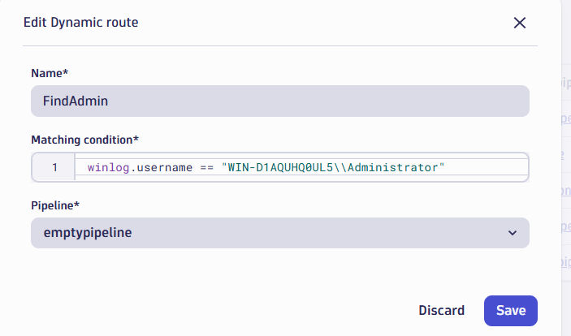

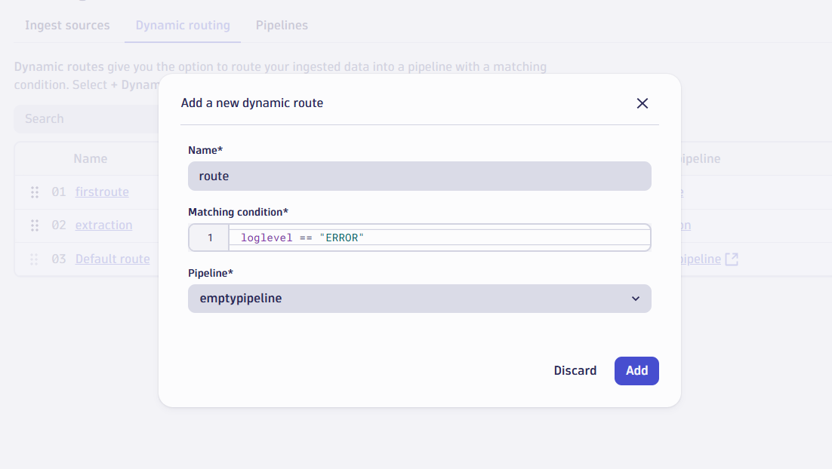

Under setting you can create new bucket

🡪Setting🡪Storage management and assign it

